Teaching Note – Module 2

Regressions

The Setting
Our goal is to estimate the demand function that a company faces. Recall that the general form of a linear demand function is:
$$Q=a+bP$$
In particular, we want to estimate a (the intercept) and b (the slope).
Suppose you are given data coming from price experimentations. For instance, you are given the number of airline seats sold for a range of different prices that were varied randomly (independent of other factors that could affect demand). This is the example we have seen in class.
The first thing you might want to do is to plot these data, to eyeball them:

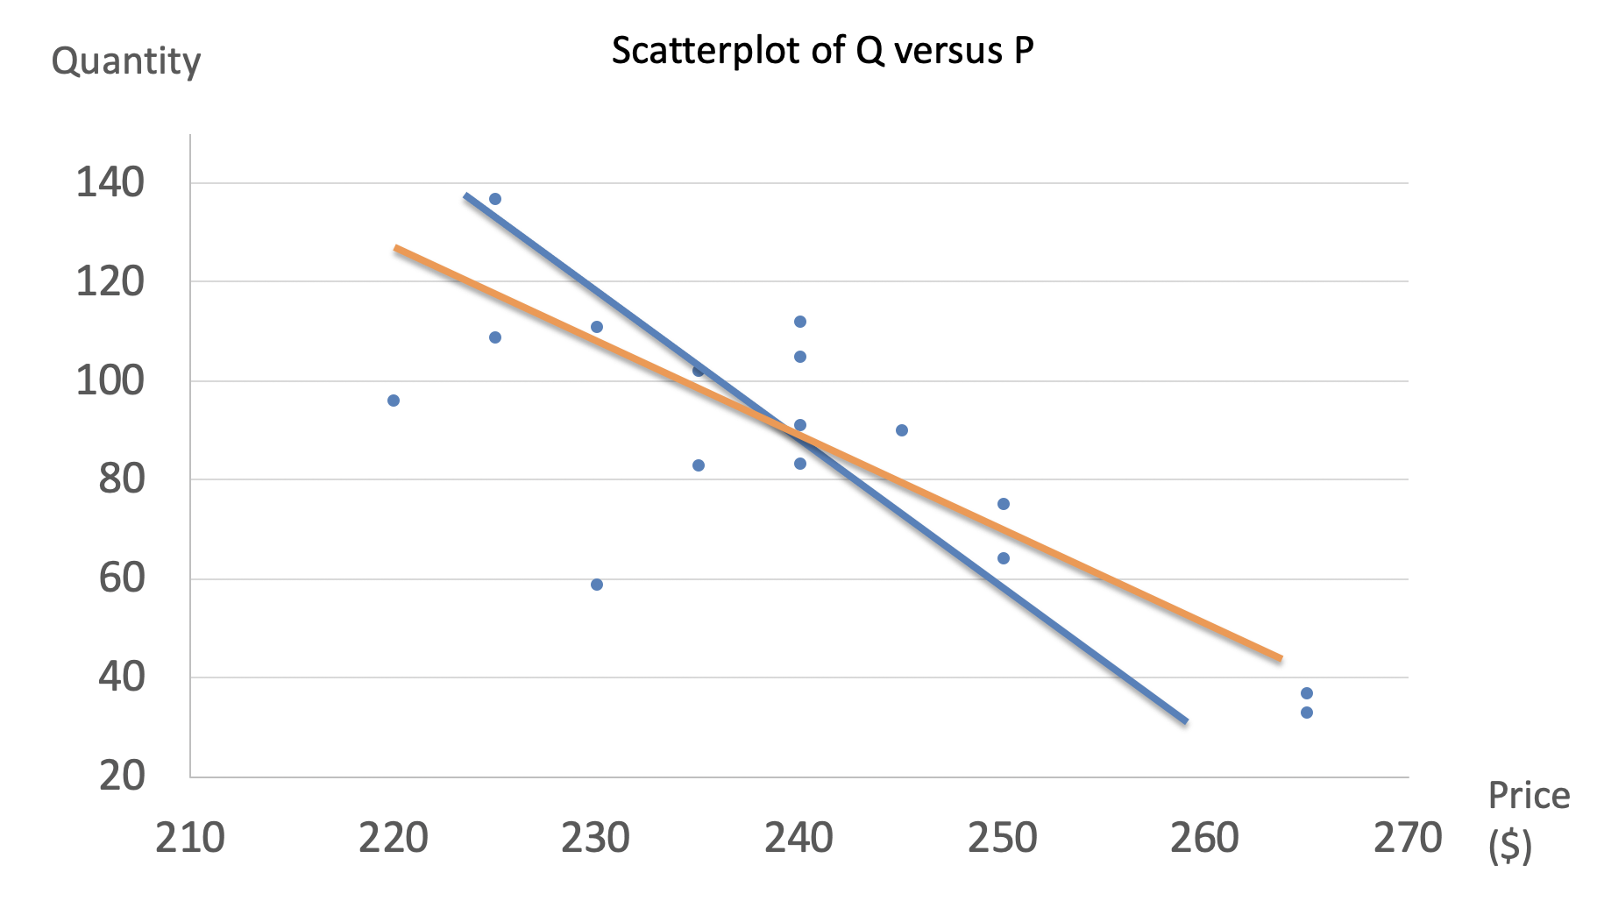

The data seem to display a negative relationship between P and Q, much like a demand curve. But the points are "cloudy" – they do not align perfectly along a line. Nevertheless, we roughly see a linear relationship.
How to estimate a linear demand curve
First, you might be tempted to just draw a line through the data. If you did that, you would probably try to pick a line that is "close" to the points, on average. If you did that manually, you could come up with several lines that "look" equally close to the points. How do you choose which one is best?
Once again, we want to estimate the parameters a (the intercept) and b (the slope) of the following equation:
$$Q=a+bP$$
Regression analysis picks one criterion to choose the "best" estimates of a and b. The criterion is to pick the slope and position of the line to minimize the sum of squares of the vertical distances from the line to the data points. We call that way to estimate the position and slope of the line least squares estimation, or ordinary least squares (OLS). The algorithm is described in the next Figure.

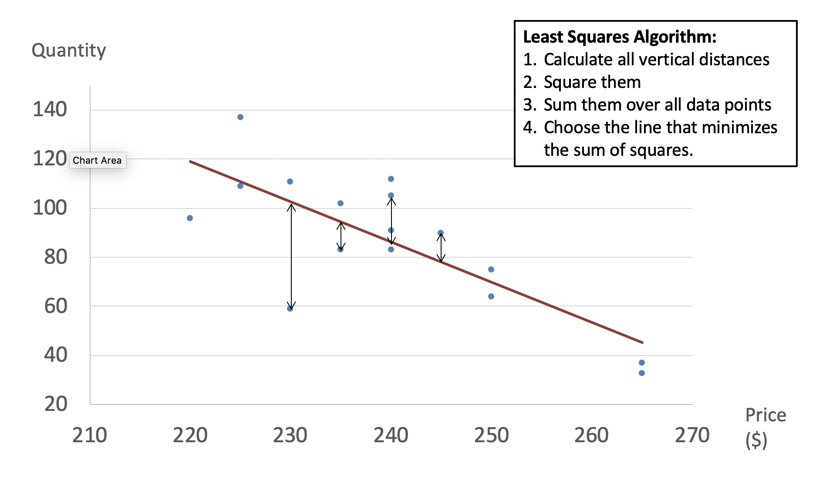

It seems complicated, but fortunately, you won't have to do all that manually. The computer will do it for you! It will take a fraction of a second for the computer to give you its estimates of a and b from the data that you feed in.

If you implement regression analysis in Excel with the data on airline tickets given in class, you will obtain:
$$Q=478.55-1.63P$$
That is, above, a=478.55 and b=-1.63. The interpretation is that if you sell tickets at a price of zero, you will sell 478.55 tickets. And for every $1 increase in the price of tickets, you will sell 1.63 fewer tickets.
Diagnostics
Excel will not just give you a and b. It will produce many more diagnostic statistics. The output you will get looks something like this:
Regression Statistics
Multiple R | 0.765
R Square | 0.586
Adjusted R Square | 0.556
Standard Error | 18.607
Observations | 16
ANOVA
 | df | SS | MS | F | Significance F
Regression | 1 | 6858.828 | 6858.828 | 19.810 | 0.001
Residual | 14 | 4847.152 | 346.225
Total | 15 | 11705.979
 | Coefficients | Standard Error | t Stat | P-value | Lower 95% | Upper 95%
Intercept | 478.547 | 88.039 | 5.436 | 0.000 | 289.722 | 667.372
Own Price | -1.633 | 0.367 | -4.451 | 0.001 | -2.419 | -0.846

We won't worry about all the statistics in this table. We will focus on the most important ones, which I have circled in red.
- The coefficients. This is what we care about the most: they are the estimates of a (intercept) and b (slope) discussed above.
- The t-stats and confidence interval. More precisely, the t-statistics. For each coefficient, they represent how accurately the coefficient is estimated. A t-stat with an absolute value above 2 indicates that you can be at least 95% certain that the coefficient is different from zero. The higher the absolute value of the t-stat, the better. Here, we are doing pretty well since the t-stat is -4.45, giving us 99.9% confidence that b is not zero. We are also 95% certain that b is between -2.42 and -0.85, as indicated by the confidence interval (“Lower 95%” and “Upper 95%”).
- The R-square. The R-square gives us a notion of the overall quality of our model – that is, how good are we overall at explaining the variation in Q with variation in P. Here, the R-square is 0.586. That means the price of the tickets alone explains 58.6% of the variation in the quantity sold. In the figure above, if all the data points were arrayed exactly on a line, R-square would be one. Price would perfectly predict quantity. We can see graphically that this is not the case here. The more cloudy the data points around the line, the lower the R-square. The closer the data points are to the line on average, the higher the R-square. We want a high value of the R-square, but that is sometimes hard to obtain.

Multivariate Regression
What could we do to improve the explanatory power of our model? The answer lies in multivariate regression. That is, instead of only trying to predict quantity with price, we will add explanatory variables. In class, we have seen that there are many determinants of demand. Among them are the income of your customers (which influences demand positively for normal goods, and negatively for inferior goods) and the prices of complements and substitutes. So one thing we could do here, for instance, is to include in our model an index of income over time, and a measure of the ticket price charged by the airline's main competitor. Income is expected to come out with a positive sign because air travel is a normal good, and the competitor's price is also expected to influence demand positively: when our competitor raises prices, consumers will switch to our product. Let's add those two variables and estimate the model again:
Regression Statistics
Multiple R | 0.881
R Square | 0.776
Adjusted R Square | 0.721
Standard Error | 14.766
Observations | 16
ANOVA
 | df | SS | MS | F | Significance F
Regression | 3 | 9089.599 | 3029.866 | 13.896 | 0.000
Residual | 12 | 2616.380 | 218.032
Total | 15 | 11705.979
 | Coefficients | Standard Error | t Stat | P-value | Lower 95% | Upper 95%
Intercept | 28.844 | 174.665 | 0.165 | 0.872 | -351.719 | 409.407
Own Price | -2.124 | 0.340 | -6.238 | 0.000 | -2.865 | -1.382
Compet Price | 1.035 | 0.467 | 2.218 | 0.047 | 0.018 | 2.051
Income | 3.089 | 0.999 | 3.093 | 0.009 | 0.913 | 5.266

A few additional points:
- The estimated coefficients on a and b have changed. The intercept (a) no longer has a natural interpretation here. It is the number of tickets sold if own price is zero, competitor's price is zero and the income index is zero. Of course, these conditions are unlikely to ever hold. The coefficient on own price (b) is now -2.124, and its t-stat has risen to -6.24. So the demand curve is slightly steeper, and we can be even more confident of the negative relationship between price and quantity. That means there will be less uncertainty on our choice of the best Q and P, so it is good news!
- The estimates on competitor's price and income are positive as expected. They also both have t-stats that are greater than 2, meaning that they are individually predictive of demand. So, we confirm that air travel is a normal good and that the competitor's product is a substitute for ours.
- The R-square has increased to 0.776. That means we have improved the overall quality of our model, and can now explain 77.6% of the variation in quantity sold. Is that good? There is no absolute standard or cutoff for a "good" R-square, but it's pretty high.
We now have a more precisely estimated demand curve:
$$Q=28.84-2.12P+1.04CompetPrice+3.09Income$$

There are many other possible criteria. We won't study them in class. Least squares estimation has many good properties and is by far the most widespread method that is used in econometrics.

